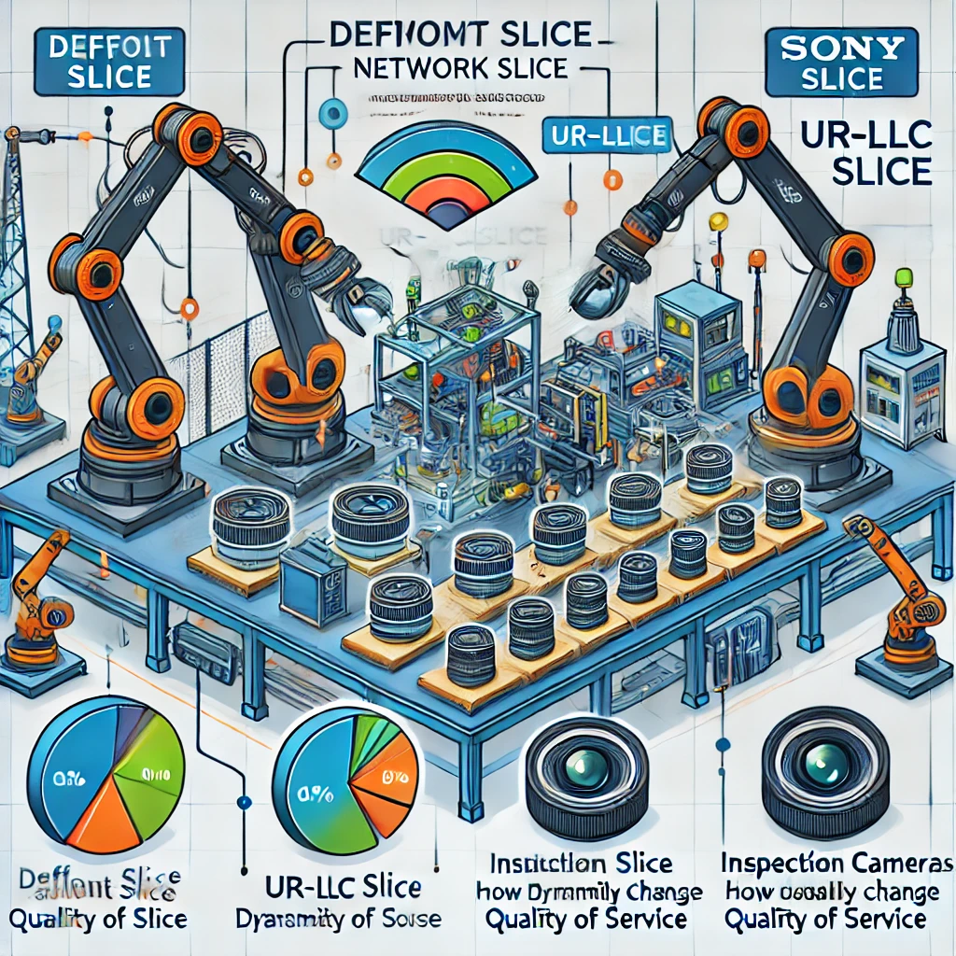

### **Use Case: Dynamic Network Slice Management in Sony Camera Manufacturing**

**Background:** Sony's camera manufacturing plant focuses on high-precision assembly, requiring real-time quality control to ensure product excellence. The plant leverages advanced 5G network slicing and Quality of Service (QoS) adjustments to manage different stages of the assembly process.

**Scenario: Adaptive Network Slicing and QoS Switching**

1. **Default Slice for General Monitoring**
   * **Use Case**: During regular operations, the assembly line runs on a Default Slice, which is configured for standard data transmission.
   * **Quality of Service (QoS)**: QoS Level 8 — Standard throughput and reliability.
2. **Switch to UR-LLC Slice for Precision Tasks**
   * **Use Case**: For tasks requiring ultra-low latency and high reliability, such as verifying lens alignment with inspection cameras, the system dynamically switches to a UR-LLC Slice.
   * **Quality of Service (QoS)**: QoS Level 133 — Ensures ultra-reliable low-latency communication.
   * **Example**:
     + **Scenario**: An inspection camera detects a flaw during the lens alignment phase.
     + **Action**: UR-LLC Slice is enabled, switching the camera and associated sensors to the high-priority slice, ensuring zero-delay communication.
     + **Outcome**: Robotic arms receive instant commands to either correct the lens or remove the unit from the production line.
3. **Dynamic Quality of Service (QoS) Adjustment**
   * **Adjustment**: As the process transitions between general assembly and precision inspection, the QoS is dynamically adjusted:
     + **Before Inspection**: QoS Level 8 (Default)
     + **During Inspection**: QoS Level 133 (High Priority)
     + **After Inspection**: Reverts back to QoS Level 8.
   * **Impact**: This dynamic adjustment ensures that critical stages receive the necessary bandwidth and reliability, reducing the risk of manufacturing defects.

**Summary:** This use case demonstrates how dynamic switching between Default and UR-LLC network slices, coupled with real-time QoS adjustments, optimizes Sony’s camera manufacturing process. By leveraging 5G slicing, Sony achieves high precision, low-latency operations during critical inspection phases, maintaining product quality and operational efficiency.